Regional Operational Plan DF.#R.YYYY.XX

Operational Plan: Cook Inlet Chinook marine sport harvest assessment

by

Carol M. Kerkvliet, Michael D. Booz and Martin Schuster

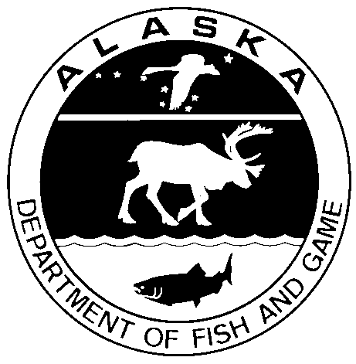

XXXX 2018

Alaska Department of Fish and Game Divisions of Sport Fish and Commercial Fisheries

Symbols and Abbreviations

The following symbols and abbreviations, and others approved for the Système International d'Unités (SI), are used without definition in the following reports by the Divisions of Sport Fish and of Commercial Fisheries: Fishery Manuscripts, Fishery Data Series Reports, Fishery Management Reports, and Special Publications. All others, including deviations from definitions listed below, are noted in the text at first mention, as well as in the titles or footnotes of tables, and in figure or figure captions.

**Weights and measures (metric)**

centimeter cm

deciliter dL

gram g

hectare ha

kilogram kg

kilometer km

liter L

meter m

milliliter mL

millimeter mm

**Weights and measures (English)**

cubic feet per second ft3/s

foot ft

gallon gal

inch in

mile mi

nautical mile nmi

ounce oz

pound lb

quart qt

yard yd

**Time and temperature**

day d

degrees Celsius °C

degrees Fahrenheit °F

degrees kelvin K

hour h

minute min

second s

**Physics and chemistry**

all atomic symbols

alternating current AC

ampere A

calorie cal

direct current DC

hertz Hz

horsepower hp

hydrogen ion activity pH

(negative log of)

parts per million ppm

parts per thousand ppt,

‰

volts V

watts W

**General**

Alaska Administrative

Code AAC

all commonly accepted

abbreviations e.g., Mr., Mrs., AM, PM, etc.

all commonly accepted

professional titles e.g., Dr., Ph.D.,

R.N., etc.

at @

compass directions:

east E

north N

south S

west W

copyright ©

corporate suffixes:

Company Co.

Corporation Corp.

Incorporated Inc.

Limited Ltd.

District of Columbia D.C.

et alii (and others) et al.

et cetera (and so forth) etc.

exempli gratia

(for example) e.g.

Federal Information

Code FIC

id est (that is) i.e.

latitude or longitude lat or long

monetary symbols

(U.S.) $, ¢

months (tables and

figures): first three

letters Jan,...,Dec

registered trademark ®

trademark ™

United States

(adjective) U.S.

United States of

America (noun) USA

U.S.C. United States Code

U.S. state use two-letter abbreviations (e.g., AK, WA)

**Mathematics, statistics**

*all standard mathematical*

*signs, symbols and*

*abbreviations*

alternate hypothesis HA

base of natural logarithm *e*

catch per unit effort CPUE

coefficient of variation CV

common test statistics (F, t, χ2, etc.)

confidence interval CI

correlation coefficient

(multiple) R

correlation coefficient

(simple) r

covariance cov

degree (angular ) °

degrees of freedom df

expected value *E*

greater than >

greater than or equal to ≥

harvest per unit effort HPUE

less than <

less than or equal to ≤

logarithm (natural) ln

logarithm (base 10) log

logarithm (specify base) log2, etc.

minute (angular) '

not significant NS

null hypothesis HO

percent %

probability P

probability of a type I error

(rejection of the null

hypothesis when true) α

probability of a type II error

(acceptance of the null

hypothesis when false) β

second (angular) "

standard deviation SD

standard error SE

variance

population Var

sample var

Regional Operational plan DF.#R.YYYY-XX

**Cook inlet chinook marine sport harvest assessment**

by

Carol M. Kerkvliet, Michael D. Booz and Martin Schuster

Alaska Department of Fish and Game, Sport Fish Division, Homer

Alaska Department of Fish and Game  
Sport Fish Division

MM 2018

The Regional Operational Plan Series was established in 2012 to archive and provide public access to operational plans for fisheries projects of the Divisions of Commercial Fisheries and Sport Fish, as per joint-divisional Operational Planning Policy. Documents in this series are planning documents that may contain raw data, preliminary data analyses and results, and describe operational aspects of fisheries projects that may not actually be implemented. All documents in this series are subject to a technical review process and receive varying degrees of regional, divisional, and biometric approval, but do not generally receive editorial review. Results from the implementation of the operational plan described in this series may be subsequently finalized and published in a different department reporting series or in the formal literature. Please contact the author if you have any questions regarding the information provided in this plan. Regional Operational Plans are available on the Internet at: <http://www.adfg.alaska.gov/sf/publications/>

Carol M. Kerkvliet, Michael Booz and Martin Schusterr,

Alaska Department of Fish and Game, Sport Fish Division,

3298 Douglas Place, Homer, AK

This document should be cited as:

Kerkvliet, Carol, M., Michael Booz and Martin Schuster. 2018. Cook Inlet Chinook marine sport harvest assessment. Alaska Department of Fish and Game, Sport Fish Division, Regional Operational Plan ROP.DF#R.YY-XX, Homer.

The Alaska Department of Fish and Game (ADF&G) administers all programs and activities free from discrimination based on race, color, national origin, age, sex, religion, marital status, pregnancy, parenthood, or disability. The department administers all programs and activities in compliance with Title VI of the Civil Rights Act of 1964, Section 504 of the Rehabilitation Act of 1973, Title II of the Americans with Disabilities Act (ADA) of 1990, the Age Discrimination Act of 1975, and Title IX of the Education Amendments of 1972.

**If you believe you have been discriminated against in any program, activity, or facility please write:**

ADF&G ADA Coordinator, P.O. Box 115526, Juneau, AK 99811-5526

U.S. Fish and Wildlife Service, 4401 N. Fairfax Drive, MS 2042, Arlington, VA 22203

Office of Equal Opportunity, U.S. Department of the Interior, 1849 C Street NW MS 5230, Washington DC 20240

**The department’s ADA Coordinator can be reached via phone at the following numbers:**

(VOICE) 907-465-6077, (Statewide Telecommunication Device for the Deaf) 1-800-478-3648,

(Juneau TDD) 907-465-3646, or (FAX) 907-465-6078

**For information on alternative formats and questions on this publication, please contact:**

ADF&G, Division of Sport Fish, Research and Technical Services, 333 Raspberry Rd, Anchorage AK 99518 (907) 267-2375

Signature/Title Page

|  |  |
| --- | --- |
| Project Title: | Cook Inlet Chinook marine sport harvest assessment |
| Project leader(s): | *Carol M. Kerkvliet, Fishery Biologist III, Michael Booz, Fishery Biologist II and Martin Schuster Fishery Biologist II* |
| Division, Region and Area | *Sport Fish Division, Region II* |
| Project Nomenclature: |  |
| Period Covered | January 2018 – December 2018 |
| Field Dates: | April– August 2018 |
| Plan Type: | Category III |

**Approval**

|  |  |  |  |  |  |  |  |  |  |  |
| --- | --- | --- | --- | --- | --- | --- | --- | --- | --- | --- |
| Title |  | Name | | |  | Signature | | |  | Date |
| Area Manager |  | Carol M. Kerkvliet | | |  |  | | |  |  |
| Assistant Area Manager |  | Michael D. Booz | | |  |  | | |  |  |
| Fisheries Biologist II |  | Martin Schuster | | |  |  | | |  |  |
| Biometrician |  | Ben Buzzee | | |  |  | | |  |  |
| Research Coordinator |  | Tim McKinley | | |  |  | | |  |  |
| Regional Supervisor |  | Tom Vania | | |  |  | | |  |  |
| GCL Representative |  | Andy Barclay | | |  |  | | |  |  |
| **Chinook Salmon Research Initiative Approval** | | | | | | | | | | |
| Title | | |  | Name | | |  | Signature |  | Date |
| Fish and Game Coordinator | | |  | Ed Jones | | |  |  |  |  |
| Fisheries Scientist | | |  | James Hasbrouck | | |  |  |  |  |
| Fisheries Scientist | | |  | Bill Templin | | |  |  |  |  |

TABLE OF CONTENTS

Page

LIST OF TABLES vi

LIST OF figures vi

LIST OF APPENDICES vi

abstracT 7

Purpose 7

Objectives 8

Secondary Objectives 9

Methods 9

Study Design 9

Sample Size – Proportion of Harvest by Reporting Group (Objective 1) 10

Sample Size – Total Harvest by Reporting Group (Objective 2) 11

Sample Size – Proportion of Harvest from Ninilchik River, Crooked Creek or Deception Creek with a CWT (Objective 3) 11

Sample size – Age/Sex/Length and Maturity (Objective 4) 11

Design Specifics By Port 12

Homer 12

Anchor Point, Deep Creek and Whiskey Gulch 13

Data Collection and Reduction 14

Biological Sampling 14

Angler Interviews 15

Data Reduction 15

Laboratory Analysis 16

Assaying genotypes 16

Laboratory Failure Rates and Quality Control 16

Statistical Analysis 16

Genetic baseline 16

Mixed-stock analysis 17

The estimated proportion of harvest with a CWT from Ninilchik River, Crooked Creek, or Deception Creek and the 90% confidence limits will be calculated by estimating the mean and the 5% and 95% quantiles of the posterior distribution. 18

Stock Specific Harvest by Reporting Group 18

Maturity, and Age, Sex and Length Compositions of Chinook Salmon in the Marine Sport Harvest 19

BUDGET SUMMARY 21

Schedule and Deliverables 22

RESPONSIBILITIES 23

Principal Investigator 23

Consulting Biometrician 23

Sampling Crew 23

references cited 24

Appendix A 32

**Salmon Species Identification** 33

**Sex** 33

**Maturity** 33

**Length Measurements** 34

**Scale Removal** 34

**Date Caught:** Record month and day the fish was caught. 39

**Water Type:** Circle saltwater (usually) or freshwater (**only** possible with select samples). 39

**Name of Place Fished:** Record the area where fish was caught, being as specific as possible, including a descriptor of the area. 39

Appendix B 43

Appendix C 47

# LIST OF TABLES

Table Page

Table 1.- Mean SWHS harvest estimates of Chinook Salmon harvest in the Cook Inlet marine sport fishery, 2013–2016. 26

Table 2.- Sampling and subsampling rates for 2014–2017. 27

Table 3.- Anticipated Chinook salmon tissue samples to collect for mixed-stock analysis from Cook Inlet marine sport fisheries during 2018. 28

# LIST OF figures

Figure Page

Figure 1.-Boundaries of the Lower Cook Inlet Management Area for Division of Sport Fish. This management area is further divided into Upper Cook Inlet area (north of Bluff Point), and Lower Cook Inlet area (south of Bluff Point including Kachemak Bay) from April 1 to August 31. 29

Figure 2.-Reporting groups . 30

Figure 3.-Marine waters salmon statistical areas from approximately one mile north of the Ninilchik River south to the latitude of Cape Douglas. 31

**Figure 4.** Length measurement is mid-eye to fork of tail (MEFL) rounded to the nearest 5 mm. 34

# LIST OF APPENDICES

Appendix Page

Appendix A.- Sampling information. 46

Appendix B.- Biological and interview data sampling form…………………………………………………………

Appendix C.- Technician field Schedule, 2018……………………………………………………………………….

# abstracT

Cook Inlet saltwaters support a diversity of year-round Chinook salmon sport fisheries that primarily occur in the Lower Cook Inlet Management Area. Harvest within these fisheries is comprised of both local Cook Inlet stocks and non-local stocks. From early April through the end of August, mature Chinook salmon are harvested in the summer fishery as they migrate to Cook Inlet streams to spawn. This project will sample the Chinook salmon sport harvest to determine the percentage of coded wire tagged Chinook salmon from Cook Inlet stockings in the harvest, use mixed stock genetic analysis to assess harvest by five genetic reporting groups and area. Sport Fish Division is responsible for coded wire tag recovery, genetic tissue samples and associated biological and effort data. Tissue samples will be sent to the Division of Commercial Fisheries Gene Conservation Laboratory, which will be responsible for the genetic mixed stock analysis. Survey areas will include the Homer Harbor and Anchor Point and Deep Creek tractor launches and marine access areas.

Key words: Chinook salmon, Cook Inlet, sport fishery, genetic mixed stock analysis, MSA.

# Purpose

The purpose of this project is to characterize the harvest of Chinook salmon in the Cook Inlet marine sport fishery. This project will collect and analyze genetic tissue samples along with age, sex and length (ASL) data and will also collect the heads of adipose fin clipped (AFC) Chinook salmon. Samples will be collected from the Cook Inlet marine sport fishery during the Summer Fishery, which encompasses April 1 through August 31. Genetic samples are needed to estimate the relative percentage of Chinook salmon in the marine sport fishery by 5 genetic reporting groups. Alaska Department of Fish and Game (ADF&G), Sport Fish Division (SF) is responsible for the collection of genetic tissue samples, ASL, and heads from AFC fish. Tissue samples will be sent to the ADF&G, Division of Commercial Fisheries (DCF) Gene Conservation Laboratory (GCL), which will be responsible for genetic mixed stock analysis (MSA). Heads from AFC will be sent the ADF&G CF Mark, Age, and Tag Laboratory (Tag Lab) in Juneau for coded wire tag (CWT) reading.

In 2012, data gap analysis was conducted by ADF&G in response to the Alaska-wide downturns in Chinook salmon productivity and abundance (ADF&G Chinook Salmon Research Team, 2013). The team selected a suite of 12 indicator Chinook salmon stocks from an array of geographically distinct stocks that represented differing migratory patterns and environments. The two largest producers of Chinook salmon within Cook Inlet (Kenai and Susitna River) were selected to be included as two of the twelve indicator stocks. Additionally, stock-specific harvest of Chinook salmon in the Cook Inlet marine sport fishery was identified as one of many information gaps hindering an understanding of the reason for the downturn in productivity.

Cook Inlet saltwaters support a diversity of year-round Chinook salmon sport fisheries that primarily occur in the Lower Cook Inlet Management Area (LCIMA, Figure 1). Feeder (immature) Chinook salmon are harvested year-round, while locally stocked (Cook Inlet hatchery-reared) and spawner (mature) Chinook salmon are harvested April through August. Cook Inlet stocks migrating through the LCIMA with early-run timing (April through mid-July) include drainages from the lower Kenai Peninsula (Anchor River, Deep Creek, Ninilchik River, and Stariski Creek), upper Kenai Peninsula (Kenai and Kasilof rivers) and northern Cook Inlet (Susitna River). Cook Inlet stocks with late-run timing (late June through August) include stocks from the Kenai River and, to a lesser extent, the Kasilof River.

In Upper Cook Inlet (UCI[1]; salt waters north of Bluff Point latitude 59°40’), Chinook salmon are primarily harvested in nearshore waters from Bluff Point north to Ninilchik. In Lower Cook Inlet (LCI; marine water south of Bluff Point including Kachemak Bay) Chinook salmon are harvested at stocked terminal fishery locations and by trolling in nearshore and offshore waters. Feeder, spawner, and stocked Chinook salmon support the harvest in both UCI and LCI. Negligible sport fishing occurs in salt waters north of the latitude of the Ninilchik River although large spawning populations of Chinook salmon originate from this area and migrate through when returning to spawn.

Regulations in Cook Inlet salt waters have been structured to regulate Chinook salmon sport fisheries temporally and geographically and have been refined to restrict the harvest of Cook Inlet stocks. MSA results from 2014 through June 2016 were provided to the Alaska Board of Fisheries at the 2016 LCI finfish meeting (Barclay et al. 2016). The percentage of Cook Inlet Chinook salmon reporting groups was highest in Upper Cook Inlet waters during the early run, with combined contributions of 24.7%, 19.5%, and 10.1% in 2014, 2015, and 2016, respectively. Contributions of the *Outside Cook Inlet* reporting group in Lower Cook Inlet harvest samples was 97.9% and 99.0% in the summer fishery for 2014 and 2015, respectively and 99.8% in the winter fishery for both 2014 and 2015. During the meeting, the board modified Cook Inlet marine sport fishing regulations to better align for when mature Chinook salmon are present in Cook Inlet (April 1 – August 31; Summer Fishery) and when they are essentially absent (September 1 – March 31; Winter Fishery). During the Summer Fishery, sport fishing regulations allow a 5 Chinook salmon annual limit for fish 20 inches or longer for all Cook Inlet waters; and in UCI marine waters the bag and possession limit is 1 Chinook salmon per day of any size, and 2 Chinook salmon per day of any size in LCI marine waters.

Work to be completed in 2018 under this operational plan is funded by the ADF&G Division of Sport Fish. This work builds upon research completed from 2014 to 2016 and funded by the State of Alaska’s Chinook Salmon Research Initiative and Pacific States Marine Fisheries Commission (Grant No. 16-100G)

# Objectives

1. Estimate the proportion of Chinook salmon harvested by reporting group for each time and area stratum such that the estimated proportions are within 10% of the true values 90% of the time.
2. Estimate the harvest of Chinook salmon by reporting group, area and time such that the estimates are within 40% of the true value 90% of the time.
3. Estimate the combined proportion of Chinook salmon harvested that received a CWT and originated from Ninilchik River, Crooked Creek, or Deception Creek such that the estimate is within 10% of the true value 90% of the time.
4. Estimate the age, sex, length and maturity composition of Chinook salmon harvested by area and time such that the estimated percentages are within 10% of the true values 95% of the time.

## Secondary Objectives

1. Collect genetic tissue and biological samples from 25% of Chinook salmon harvested in the Cook Inlet marine sport fishery.
2. Examine 25% of Chinook salmon harvested in the Cook Inlet marine sport fishery for adipose fin clips.
3. Estimate the proportion of mature Chinook salmon harvested by reporting group for the entire Cook Inlet marine sport fishery such that the estimated proportions are within 0.10 of the true values 90% of the time.

# Methods

The general study design for this project is to sample the marine sport harvest for both charter (guided) and private (unguided) Chinook salmon during the Summer Fishery. Sampling is designed to estimate the harvest contribution of Chinook salmon originating from Cook Inlet stockings and to use MSA to assess the percent harvest from the following five genetic reporting groups (Figure 2).

1. *Outside Cook Inlet* (populations from outside of Cook Inlet)
2. *West/Susitna* (Western Cook Inlet, Yentna River, and Susitna River populations)
3. *Knik/Turnagain (populations from Knik Arm and Turnagain Arm)*
4. *Kenai* (Kenai River populations)
5. *Southern Kenai Peninsula (Anchor River, Stariski Creek, Deep Creek, Ninilchik River, and Kasilof River populations)*

The SWHS provides total estimates of the harvest and catch of the corresponding sport fisheries through a mail survey of participating households. In 2017, the SWHS was modified to reflect regulation changes at the 2016 Board of Fisheries Meeting described above; as a result, the SWHS can no longer be used to produce separate estimates of early and late run Chinook salmon in waters north of the latitude of Bluff Point in UCI (Figure 1).

## Study Design

This project collects genetic tissue samples and biological data of the Chinook salmon harvested by sport anglers at the major ports in Cook Inlet during the Summer Fishery. The sport harvest will be sampled at the Homer small boat harbor, at Anchor Point and Deep Creek tractor launches, and at Whiskey Gulch beach. Based on available charter logbook data, these areas likely account for most of Chinook salmon landings in Cook Inlet. To sample proportionally over the entire season of the fishery, adaptive sampling will be used as needed to sample the harvest when there are spatial and temporal shifts in harvest.

The goal will be to sample as many Chinook salmon as possible while distributing sampling effort to allow for as representative a sample of the harvest as is possible. Days within a sampling week will be selected to maximize the number of Chinook salmon sampled (while ensuring that the sampling crew has two contiguous days-off each work week). A total of five technicians will be assigned to this project (1 crewleader and 4 port samplers). Four technicians will be assigned to sample the Homer small boat harbor and launch sites north of Bluff Point.

Sampling consists of two primary components (Appendix A):

1. Genetic tissue, biological sampling for ASL data, CWT head collection and maturity.
2. Angler interviews to identify the geographic distribution (by statistical area code) of the harvest, user group (charter/private), hours fished, and fish released private) (Figure 3).

Biological sampling and angler interviews will be conducted simultaneously and entered on a data entry form; Appendix B). Statistical areas will be used to determine area of harvest. For harvest in UCI, date will be used to differentiate early run samples (April 1-June 24) from late run samples (June 25-August 31) (Table 1; Figure 1).

The proportion of the UCI and LCI Chinook salmon harvest returning to either the Ninilchik River, Crooked Creek or Deception Creek will be estimated using CWT recoveries. Chinook salmon from brood years 2014-2016 were released in Crooked and Deception Creeks, and salmon from brood years 2014 and 2015 were released into the Ninilchik River (Table 5). Sampling for CWT data will be conducted in concert with genetic sampling. Heads will be recovered from Chinook salmon missing an adipose fin. Returns from brood years 2014-2016 will be returning as ocean ages 1-3 year fish. Each of the heads will be scanned for a CWT. Heads will be given a uniquely numbered cinch strap obtained from the DCF Mark, Tag, and Age Laboratory which will be attached to each head (Appendix A3). The head will then be sent with a completed CWT sampling form (Appendix A3) to the Mark, Tag, and Age Laboratory for dissection and decoding of tags. Ages derived from scale readings will be proofed against ages derived from decoded CWT.

### Sample Size – Proportion of Harvest by Reporting Group (Objective 1)

The most recent available harvest estimates (2013–2016) were averaged by area and time to plan for possible summer 2018 harvest levels (Table 1). An overall sampling rate of 25% was achieved in 2014, but not achieved in 2015 and 2016. Since the estimated harvest for 2017 will not be available until fall of 2018, average harvest from 2013 to 2016 is used as a proxy to evaluate sampling rate. In 2017 sampling rate was achieved in 2017 in UCI, but not in LCI based on the 2013–2016 average (Table 2). Prior to 2016, crews were unable to achieve a sampling rate larger than 5% in the UCI late run fishery, though in 2016 crews managed to increase the UCI late run sampling rate to 18% (Table 2). In 2018, we expect to achieve an overall sampling rate of 25% based on results from 2014 through 2017 (Table 2). In the years 2014-2017 between 1,600 and 2,800 Chinook were sampled for maturity, with 125-343 fish classified as mature. If the proportion of mature fish in 2018 is similar to previous years, collecting 300 genetics samples may prove difficult. If this sample size is not obtained in 2018, then the MSA may be conducted on a pooled subsample of mature fish from all five years of sampling (2014–2018).

Resources available for this project allow 1,200 tissue samples to be processed for MSA in 2018. From 2014–2017, 300 tissue samples were allocated for each of the 4 fisheries (winter, summer, early-run and late run). We anticipate collecting more than 300 samples in the 3 fisheries selected for this study (LCI summer, UCI early-run and UCI late run). Each fishery will be subsampled for genetic analysis (Table 3). During subsampling, tissue samples from fish caught by charter and private anglers will be selected in proportion to the SWHS harvest estimates for each user group If less than 300 tissue samples are collected for any fisheries, additional samples will be subsampled from the remaining fisheries to achieve 1,200 total samples.

Assuming that the samples are representative of the harvest, both sampling error and genetic error will affect estimates of the proportion of Chinook salmon harvest by reporting group. According to sampling theory (Thompson 1987), and under a worst-case scenario of reporting groups at equal proportions, a multinomial proportion can be estimated to within 0.06 of the true values 90% of the time with a sample size of at least 300. Additional uncertainty will originate from the MSA, which has been assessed through the use of MSA proof tests using methods reported in Barclay and Habicht (2015). Results of MSA proof tests can be found in Barclay et al. 2016. Relative precision criteria were met in UCI Early, LCI Summer, and LCIMA Winter estimates generated for the 2014–2016 seasons (Barclay et al. 2016). The relative precision of the estimates for the UCI Late fishery will be less precise than estimates obtained for the other fisheries due to small sample size.

### Sample Size – Total Harvest by Reporting Group (Objective 2)

To assess the precision of estimates of harvest by reporting group, error associated with the SWHS harvest estimates must be included. Accounting for the expected precision of stock composition estimates and the variability of SWHS harvest estimates, both based on 2014–2016 data, we will be able to estimate the Cook Inlet Chinook salmon marine sport harvest by reporting groups by area to within 40% of the true values 90% of the time for the UCI and LCI Summer Fishery. The relative precision of the SWHS harvest estimate in the UCI Late fishery has approximated 40% of the true value 90% of the time for the last 5 years, and will be larger once the variability in the proportional stock composition estimate is included.

### Sample Size – Proportion of Harvest from Ninilchik River, Crooked Creek or Deception Creek with a CWT (Objective 3)

Assuming the sampled fish are representative of the harvest, under the worst-case scenario for estimating a binomial proportion we would need a total of 68 samples for our estimate to be within 10% of the true proportion 90% of the time. Since each year from 2014-2017 over 1000 fish have been sampled for maturity alone, we can expect to collect far more samples than needed.

### Sample size – Age/Sex/Length and Maturity (Objective 4)

The objective criterion (± 0.10 with 95% confidence level) for estimating the age composition of Chinook salmon harvested in the Cook Inlet marine sport fishery should be achieved with approximately 170 scale samples. To arrive at this sample size, we will assume 25% scale regeneration rate and the worst-case scenario for multinomial proportions (Thompson 1987). It is likely that there will be more than 170 scale samples collected for each reporting group and subsampling may be required to best represent the age composition. A sample size of 170 fish per time and area stratum will be sufficient to meet the precision criteria for Sex and Length estimates.

## Design Specifics By Port

At all ports, the overall sampling design is as described above in the Study Design section of this Operational Plan. The general design features for sample selection and the data analysis procedures are the same for all locations. The following sections outline details regarding the specifics of access locations, days of the week, periods of the day, and allocation of technician shifts that are unique to each major port. Additionally, site specific details regarding data collection and recording procedures will be outlined in further detail in the technicians’ field procedure manual.

A total of 4 technicians are assigned to the project, working 7.5 hours each scheduled day. The technicians are scheduled such that 7 days a week are covered in the Homer Harbor(the port receiving the most fishing effort based on charter logbook information and experience obtained during the 2014–2017 field seasons), and 5 days of the week are covered in Anchor Point, Whiskey Gulch, and Deep Creek. Two technicians will be assigned to the Homer Harbor, and the remaining 2 technicians will be assigned to cover either Anchor Point, Deep Creek, or Whiskey Gulch. Anchor Point and Deep Creek were treated as separate ports from 2014-2017 and Whiskey Gulch was not sampled from 2014-2017. Grouping these three ports together will create better flexibility to be adaptive to locations where effort is highest. If effort increases in Anchor Point and/or Deep Creek, technician schedules may be adjusted to intercept the increased harvest. The focus of these intercepts is to maximize the number of samples collected from fish returning to UCI reporting groups when fishing effort increases. During the early-run fishery north of Bluff Point, we assume that effort will likely increase from mid-May through early June when anglers target Cook Inlet stocks with early run timing. For the late-run fishery north of Bluff Point, we anticipate increased effort in the first three weeks of July from Kenai River late-run Chinook salmon. Sampling start times may also be adjusted to sample Chinook salmon harvest from anglers returning to port earlier in the day. All weekends and holidays will be worked, and technicians will get two consecutive days off each week (Appendix B).

### Homer

There are numerous exit points in the LCI fishery, including the communities of Homer, Seldovia, Nanwalek, and Port Graham, as well as several hundred private docks along the south side of Kachemak Bay from Bear Cove to Kasitsna Bay (ADF&G 1993; page A-37). Because it would be cost-prohibitive to sample all these exit points, the fishery will be sampled only at the major access point, the city harbor on the Homer Spit.

The Homer Chinook salmon marine sport fishery will be surveyed from April 1 to August 31, 2018. This location will be sampled with at least one sampler 7 days a week. When Chinook salmon harvest increases in the Homer Harbor, the sampling effort will increase to have up to two samplers daily. Sampling will generally begin at 1300 hours but may need to begin earlier in the day to account for the tendency of private vessels to arrive earlier than charter vessels. The harbor and associated facilities cover a large area, making it difficult to distribute sampling effort in a representative manner. When sampling fish, the technician will spread sampling effort between the public fish cleaning stations at Ramps 4 and 6, boats cleaning fish on deck, the boat ramp, the fish cleaning table near the Nick Dudiak Fishing Lagoon, and numerous charter cleaning facilities. Ideally, due to the high volume of charter-caught fish, approximately 4 to 5 charter boats would be randomly selected from a list of all known charter vessels for sampling each day. The reality of sampling in the dynamic atmosphere of this harbor makes sampling problematic as upon arriving at the dock, the sampler may find any of the following scenarios; none of the charter vessels have gone out that day, some have already returned and cleaned all or a portion of their harvest, the vessel decided not to target Chinook salmon that day, or all return at once forcing a sampler to choose a single boat from the list of charter vessels. Instead, the sampler will systematically move through the cleaning locations (cleaning tables, charter offices, and vessels that clean fish on their decks) to obtain samples. In order to sample private and charter vessels in proportion to their respective harvests, private samples must also be collected daily, and, since the behavior of these anglers is more diverse than charter anglers, more interviews will be required. Sampling will also be distributed between private and charter caught fish throughout the shift to spread samples over time.

### Anchor Point, Deep Creek and Whiskey Gulch

The beaches near the mouths of the Anchor River and Deep Creek are the primary access areas and likely account for the majority of Chinook salmon landings from the UCI fishery. The Anchor Point and Deep Creek Chinook salmon marine sport fisheries will be surveyed from approximately May 1 to August 31, the time frame during which the tractor launches operate. However, at times, the early- and late-run fisheries are accessed at Whiskey Gulch. As needed, samplers will periodically be assigned to cover Whiskey Gulch to increase sampling of the early- and late-run stocks. When Chinook salmon harvest declines in late July or early August (this has been observed annually with the project for the last 4 years), sampling effort will also decline. The possibility of differences in spatial distribution of harvest makes it prudent to distribute sampling effort such that the resulting harvest reported in interviews and biological sample sizes are proportional to harvest at these sites. Determining the appropriate allocation of sampling effort is problematic because: (1) estimates of neither the overall sport harvest, nor private harvest are available for Deep Creek and Anchor Point separately; (2) sampling efficiency differs by port; (3) sampling efficiency differs by technician; (4) the distribution of harvest between the sites is dynamic; and 5) differences in potential trip duration between charter and private anglers.

In May and early June, Anchor Point, Deep Creek, and Whiskey Gulch access points will be sampled up to 7 days a week with up to three technicians. If Chinook salmon harvest increases in the Homer Harbor after early June, then the sampling at these locations may be reduced to five days a week. Sampling will return to 7 days a week in July, when we anticipate increasing harvest at these locations. After the late-run Cook Inlet stocks have moved through this fishery, sampling effort will return to five days a week at these locations. Although there are no data available that describe the complete hourly pattern of boats exiting the fishery at these locations, general observations from 2014 to 2017 during Chinook salmon creel surveys have suggested that harvest in these fisheries does change temporally and geographically over the season. Technicians will primarily be scheduled to proportionally sample the harvest and sampling will generally start at 800am.

At all three locations, sampling will be conducted on the beaches and at off-beach locations. The first portion of each shift will be spent on the beach obtaining samples from private anglers or finding out where charters will be transporting their harvest for cleaning. Charter operators usually leave the beach immediately to clean fish at charter facilities or other sites located away from the beach. Sampling harvest at the tractor-launch facilities is impractical because it detains boats and disrupts the flow of traffic. Sampling at the boat ramps also requires climbing aboard large boats on trailers, where fish are often in totes or holds and cannot be laid out for sampling. Vessel owners are generally unwilling to have their boats slimed after having been cleaned and prepped for travel to cleaning facilities, RV parks and/or campgrounds; therefore, most of the sampling will be conducted at these locations.

## Data Collection and Reduction

### Biological Sampling

Harvested Chinook salmon will be sampled for genetic tissue, maturity, ASL, flesh color, and examined for the presence/absence of an adipose fin (Appendix C). The harvest of each fish will also be recorded by statistical area and user group (charter/private). Not all biological data will be collected for every fish due to angler considerations and sampling time constraints, though MSA requires statistical area, user group and adipose fin assessment for a complete genetic sample. Flesh color will be recorded for all fish that are assessed for maturity.

For genetic tissue collections a ½ inch piece from the tip of an axillary process fin will be removed from each fish and placed on a Whatman paper card in its own grid space and then stapled in place (Appendix A2). Whatman cards with tissue samples will be placed in an airtight case with desiccant beads to preserve the tissue for DNA extraction. Each Whatman card will have a unique barcode and a numbered grid, which will be recorded on data sheets for each sample. All Whatman cards will be stored at the Homer office until the end of the season and then sent to the GCL for analysis.

Maturity (immature/mature) will be determined by internal examination of the gonads for as many Chinook salmon as possible. Maturity will be assigned to males and females similar to methods used previously for UCI fisheries (Begich 2010) and outlined by Kissner (1973). Females will be classified into three categories (immature, fall spawner and spring spawner) based on the diameter of 10 continuous eggs and recorded to the nearest mm (Table 4). Male Chinook salmon will be recorded as either mature or immature based on the size of the gonads (Table 4).

To assess the age composition of the Chinook salmon harvest in each fishery, 3 scales will be taken from the left side of the body of each sampled fish, at a point on a diagonal from the posterior insertion of the dorsal fin to the anterior insertion of the anal fin, 2 rows above the lateral line (Welander 1940), and placed on an adhesive-coated card. If the scales in the preferred location cannot be obtained, another set of scales will be taken from as close to the preferred location as possible. However, scales will only be taken from the area bounded dorsally by the fourth row of scales above the lateral line, ventrally by the lateral line, and between lines drawn vertically from the posterior insertion of the dorsal fin and the anterior insertion of the anal fin. If no scales are available in the preferred area on the left side of the fish, scales will be collected from the preferred area on the right side of the fish. All data associated with scale collection will be recorded directly onto scale cards containing the sampled scales from each fish. After sampling, scales will be inspected to ensure they are clean and oriented correctly before they dry. An impression of the scales will be made in acetate using a press under 22,500 PSI and the scale growth patterns will be viewed with a 40x microfiche reader to estimate ages.

Sex will be determined using visual examination of the gonads, and will be classified as males, females or not assessed. Mid-eye to fork length (MEFL) will be measured to the nearest 5mm on all fish sampled for age. Heads from Chinook salmon with adipose fin clips (CWT heads) will be collected and identified with a uniquely numbered cinch strap.

### Angler Interviews

Technicians will attempt to contact all boat parties that targeted Chinook salmon as they exit the fishery at each access location. Because of the variety of sport fishing that occurs at these locations, if may be difficult to identify boat parties that targeted or harvested Chinook salmon. To avoid congestion due to the interview process, the interviews will be brief and conducted as anglers are securing their boats, gear, etc. for exiting the beach, launch, or harbor area.

The following information will be recorded on to datasheets for each boat-trip that harvested Chinook salmon (Appendix C).

1. Port,
2. Date and time,
3. Boat name (if charter) or private vessel designator,
4. User group (charter, private),
5. Statistical area of harvest,

Charter boat skippers, rather than crew or clients, will be interviewed to obtain accurate reporting of statistical areas and harvest location. Whenever possible, technicians will personally observe and count all harvested Chinook salmon and confirm the fish they are counting represent the entire harvest for that trip (i.e., no fish have been filleted or stored elsewhere on the vessel). Some common situations that would preclude counting the actual harvested fish include (1) some of the fish are filleted and carcasses tossed at sea, (2) some of the fish are consumed at sea, (3) some of the fish are already offloaded and carried away, (4) returning boat traffic is extremely heavy and the technician needs to conduct other interviews, or (5) taking the time to count fish will interfere with other boat launching operations and cause congestion at the boat launch or beach. When the recorded harvest is based on the charter skipper’s word, rather than an actual count, the verification field response should be no.

### Data Reduction

Technicians will return their datasheets, genetic cards, scale cards, and CWT heads to the Homer office daily and will be responsible for ensuring the recorded data are legible and accurate. The project crew leader will ensure all data are returned, legible, and entered correctly. Each technician will enter their data into an Access database daily and proof it by the end of the work day. All data will be proofed by the field crew leader or project biologists before it is finalized.

A proportionally selected subsample of readable scales will be selected from each fishery. The samples will be read using a microfiche reader and aged with methods described by Mosher (1969). Age data will be entered directly into the database. Prior to recording ages, known-age reference sets from previous years will be read until a high proportion of assigned ages agree with the reference set and differences are unbiased and independent of age. The agers scale reading accuracy will be assessed by comparing ages of samples from fish of known ages (through CWT information). Scale cards and acetate impressions will be archived at ADF&G in Homer.

At the end of the season, all interview files will be converted to SAS datasets for analysis and ASCII files for archival. The file structure of ASCII files will be documented. Excel workbooks will also be converted to SAS datasets for analysis and to ASCII files for archiving. All files will be named using conventions established by RTS.

Initial editing of biological data files will include checks of frequency listings for impossible or unlikely data and will ensure correspondence with collected age structures. After aging is complete and age data are entered, data files will be checked using a SAS or similar software program developed to spot data entry errors and outliers not detectable with frequency listings. The program outputs a list of suspect records that will then be compared to the original data.

Interview files will also be checked with a SAS or similar software program that finds erroneous data and outliers not detectable with simple range checks or frequency listings; most of these errors will be identified and corrected at the time of data entry.

Copies of edited data files will be stored on the Homer LAN server, project leader’s computer, and backed up on an external hard drive. Historic archived files and original files can be found in the same locations.

Genetic sample selection will be completed and forwarded to the GCL upon availability of Saltwater Logbook data, which is needed for temporal harvest comparisons. As laboratory analysis is contingent upon sample selection, the time frame for that analysis may have to be adjusted.

## Laboratory Analysis

### Assaying genotypes

DNA extraction and genotyping will generally follow the methods described in detail in Barclay et al. (2016). Briefly, genomic DNA will be extracted from tissue samples using a NucleoSpin® 96 Tissue Kit by Macherey-Nagel (Düren, Germany). Fluidigm 192.24 Dynamic Arrays (<http://www.fluidigm.com>) will be used to screen 42 SNP markers. The Dynamic Arrays will be read on a Fluidigm EP1 System or BioMark System after amplification and scored using Fluidigm SNP Genotyping Analysis software. Assays that fail to amplify on the Fluidigm system will be reanalyzed on a QuantStudio™ platform. The plates will be scanned on the system after amplification and genotyped using the Life Technologies QuantStudio 12K Flex Software.

Genotypes produced on both platforms will be imported and archived in the GCL Oracle database, LOKI.

### Laboratory Failure Rates and Quality Control

Overall failure rate will be calculated by dividing the number of failed single-locus genotypes by the number of assayed single-locus genotypes. An individual genotype will be considered a failure when a locus for a fish cannot be satisfactorily genotyped.

Quality control (QC) measures will be used to identify laboratory errors and to determine the reproducibility of genotypes. In this process, 8 of every 96 fish (1 row per 96-well plate) will be reanalyzed for all markers by staff not involved with the original analysis. Laboratory errors found during the QC process will be corrected, and genotypes will be corrected in the database. Inconsistencies not attributable to laboratory error will be recorded, but original genotype scores will be retained in the database.

## Statistical Analysis

### Genetic baseline

To estimate the proportion of Chinook salmon from outside of Cook Inlet in the Cook Inlet marine sport fishery harvest, a baseline will be used which includes 55 populations from the most current Cook Inlet baseline (Barclay and Habicht 2015),159 populations from outside of Cook Inlet and 42 SNP markers used in the coast-wide baseline (Templin et al. 2011).

### Mixed-stock analysis

Estimates of Chinook salmon stock composition and harvest by reporting group will be produced for each of the time and area stratum described above. If insufficient samples are collected in for UCI strata, then they could be combined within years.

Data will be combined from 2 sources to estimate the stock compositions of the harvest samples in each stratum. The first source will be genetic data from fish of unknown origin and the second will be known-origin data derived from coded-wire-tags or thermally marked otoliths found in fish with adipose fin clips. To incorporate the stock compositions of known origin fish with stock compositions of unknown origin fish, from genetics samples, into a combined genetic MSA, mixtures of sample size *n* will be partitioned into known (*k* = successfully identified adipose-fin clipped fish) and unknown (*u* = fish included in the MSA) components and a separate Bayesian analysis will be done on each component.

**Analysis using genetic data:** The stock composition of the mixtures will be estimated using the software package *BAYES* (Pella and Masuda 2001). *BAYES* employs a Bayesian algorithm to estimate the most probable contribution of the baseline populations to explain the combination of genotypes in a mixture sample. The prior parameters for each reporting group will be defined to be equal (i.e., a *flat* prior). Within each reporting group, the population prior parameters will be divided equally among the populations within that reporting group. A total of 4 Markov Chain Monte Carlo chains will be run with 40,000 iterations each and the first half will be discarded to remove the influence of starting values. The last half of each chain will be combined for a total posterior chain length of 80,000. We will assess the among-chain convergence of these estimates in BAYES using the Gelman-Rubin shrink factor, which compares the variation of estimates within a chain to the total variation among chains (Gelman and Rubin 1992). If a shrink factor for any stock group estimate is greater than 1.2, we will reanalyze the mixture with 80,000-iteration chains and follow the same protocol. Stock proportion estimates and the 90% confidence intervals (CI) for each mixture will be calculated by taking the mean and the 5% and 95% quantiles of the posterior distribution from the single chain output.

**Analysis incorporating known origin data:** The known component will be partitioned into 4 stocks, where *ki* is the count of known fish from stock *i*. To allow for uncertainty in the known stock composition ${ P}_{K}$, a unit Dirichlet distribution will be placed on them, resulting in the following posterior distribution:

|  |  |
| --- | --- |
| . | (1) |

To allow for uncertainty in the known proportion of the mixture , a uniform distribution will be placed on it resulting in the following posterior:

|  |  |
| --- | --- |
| . | (2) |

The posterior distributions from the known CWT and unknown genetic components will then be combined by the following equation to estimate the proportion of each stock $\left(p_{i}\right)$ in the mixture:

|  |  |
| --- | --- |
| $p_{i}=rp_{K,i}+(1-r)p_{U,i}$, | (3) |

where is the known proportion of the mixture, $p_{K,i}$ is stock *i*’s composition in the known portion of the mixture, and $p_{U,i}$ is stock *i*’s composition in the unknown portion of the mixture. Stock proportion estimates and 90% confidence limits for each mixture will be calculated by estimating the mean and 5% and 95% quantiles of the combined posterior distribution.

**Proportion of Harvest with CWT**

To estimate of the proportion of harvest with a CWT from Ninilchik River, Crooked Creek, or Deception Creek, we will proceed similarly to the analysis incorporating known origin data in the mixed stock analysis, except there will only be two stocks of interest, fish that have been harvested from Ninilchik River, Crooked Creek, or Deception Creek with a CWT, andall other harvested fish. We will assume counts of harvested fish from Ninilchik River, Crooked Creek, or Deception Creek with a CWT (*k*) follow a binomial distribution. To allow for uncertainty in the proportion of interest we will place an uninformative beta prior (α = β = 1) on it, resulting in the following posterior distribution:

|  |  |
| --- | --- |
| . | (4) |

### The estimated proportion of harvest with a CWT from Ninilchik River, Crooked Creek, or Deception Creek and the 90% confidence limits will be calculated by estimating the mean and the 5% and 95% quantiles of the posterior distribution.

### Stock Specific Harvest by Reporting Group

Estimates of stock specific harvest will be derived by applying the stock specific composition proportions $p_{i}$ to the stratum harvest $H$ (follows Habicht *et al.* 2012):

|  |  |
| --- | --- |
| $$H_{i}=Hp_{i}$$ | (5) |

The estimate ${\hat{H}}_{i}$ and distribution of stock specific harvest for each reporting group (*i*) will be obtained by Monte Carlo simulation. Independent realizations of the reporting group-specific harvest $H_{i}^{(k)}$ will be drawn randomly from the joint distribution of the harvest $H^{(k)}$ and stock composition $p_{i}^{(k)}$ for each stratum (K observations):

|  |  |
| --- | --- |
| $$H_{i}^{(k)}=H^{(k)}p_{i}^{(k)}$$ | (6) |

Descriptive statistics will be estimated directly from the K observations of $H_{i}^{(k)}$ with the median used as the estimate of stock specific harvest ${\hat{H}}_{i}$ and the 5th and 95th quantiles determining the bounds of the 90% CI.

Generation of stock-specific catch distributions will require an estimate of the distribution of each component. The distributions of the stock compositions $p_{i}^{(k)}$ will be the Bayesian posterior distributions of stock proportions from the mixed stock analysis described above. The harvest $H^{(k)}$ from each stratum will be assumed to follow a lognormal distribution with the mean and SD taken from the SWHS.

### Maturity, and Age, Sex and Length Compositions of Chinook Salmon in the Marine Sport Harvest

Separate estimates of maturity, age and sex compositions will be calculated for each of the time and area (fishery) strata described above. Each of these proportions of Chinook salmon harvested in each time and area stratum will be estimated as:

|  |  |
| --- | --- |
|  | (7) |

where  is the estimated proportion of salmon of age category *z*,  equals the number of fish sampled that were classified as age category *z*, and equals the number of Chinook salmon sampled for age determination.

The variance of  will be calculated by:

|  |  |
| --- | --- |
|  | (8) |

Where  is the SWHS estimate for harvest in the stratum.

The estimates of harvest by age categories in each time and area stratum will be calculated by:

|  |  |
| --- | --- |
|  | (9) |

with its variance estimated as (Goodman 1960):

|  |  |
| --- | --- |
|  | (10) |

Length, sex, maturity composition and hatchery origin are estimated using equations 6-9, substituting length, sex, maturity status or hatchery origin for age.

The variance of will be estimated by:

|  |  |
| --- | --- |
| . | (11) |

# BUDGET SUMMARY

|  |  |  |  |  |  |  |  |
| --- | --- | --- | --- | --- | --- | --- | --- |
| Proposed Field Costs: | | |  |  |  | |  |
|  |  |  | |  |  | |  |
| Line Item | Category |  | |  |  |  | 2018 Field Season Budget ($K) |
| 100 | Personnel |  | |  |  | | 104.8 |
| 400 | Sampling supplies |  | |  |  | | 3.0 |
|  |  | | |  |  | |  |
|  |  | | |  |  | |  |

Gene Conservation Laboratory Costs:

|  |  |  |  |  |  |  |
| --- | --- | --- | --- | --- | --- | --- |
| Line Item | Category |  |  |  |  | 2018 Gene Conservation Lab Budget ($K) |
| 300 |  |  |  |  | | 51.5 |
| Total |  |  |  |  | | 51.5 |

# Schedule and Deliverables

Project activities are scheduled as follows:

|  |  |
| --- | --- |
| Date | Activity |
|  |  |
|  |  |
|  |  |
|  |  |
| February - April 2018 | Hire seasonal staff |
|  |  |
| May – Late August 2018 | Sample Chinook salmon harvest |
|  |  |
| September 2018 | Edit data and transfer remaining 2018 tissue collections to GCL |
| September 2019 | Estimate ASL composition for 2018 summer fisheries. |
| September 2019 | Incorporate final SWHS estimates and subsample tissue collection for GCL |
| February - April 2019 | Harvest estimates completed by temporal, geographic strata and reporting group |
|  |  |
| September 2019  October 2019 | FDS report draft out for review  Publication of final report |
|  |  |

# RESPONSIBILITIES

## Principal Investigator

Carol Kerkvliet, Project Leader, Fishery Biologist III:

As project leader, is responsible for formulating research objectives to meet regional management goals, writes operational plan, oversees budgets, and supervises project technicians. This position will serve as the project biologist and will be responsible for hiring and training personnel and supervision of data collection. The project biologist will be responsible for collating data and transferring tissue samples, and any associated data, to Anchorage for MSA. This position will also ensure all data is in the proper format and archived with RTS at the completion of the field season and will be primary author on any reporting. Additionally, the project biologist submits invoices, manages budgets, and prepares budget requests.

Michael Booz and Martin Schuster, Project Assistants, Fishery Biologist II:

Project assistants will assist with operational planning, hiring,training personnel and data collection. This position may occasionally function as a member of the sampling crew as needed. Provide data summaries and assist with reporting.

Andy Barclay, Fishery Biologist III:

This position is the Gene Conservation Lab representative, responsible for the genetic analysis of tissue samples for MSA, managing the GCL budget, and providing group-specific proportional and harvest estimates from individual strata to the project biologist and biometrician.

Vacant, Fish and Wildlife Technician III

This position will serve as crewleader of the sampling crew. This position will be responsible for maintaining sampling supplies and equipment, proofing data. Pressing age scales. This position will ensure data are entered and proofed and function as a member of the sampling crew as needed. Brief project leader at least once a week.

## Consulting Biometrician

Ben Buzzee, Biometrician I:

This position provides guidance on sampling design and data analysis, prepares estimate of harvest of Chinook salmon by reporting group, and assists with preparation of operational plan and report.

## Sampling Crew

Vacant, Fish and Wildlife Technician II (4):

Collect biological and fishery data following procedures outlined in the operational plan, field procedure manual, and other instructions, complete data forms in an accurate and timely manner, identify sampling needs and problems, provide fishery information to the project leader for weekly fishing reports, explain the sampling program to the general public, maintain state vehicles and other equipment in good working order, and submit all necessary paperwork in a neat and timely manner. Computer data entry and/or preparation and reading of age structures.

# references cited

ADF&G (Alaska Department of Fish and Game). 1993. Kachemak Bay and Fox River Flats Critical Habitat Areas Management Plan. Alaska Department of Fish and Game, Divisions of Habitat Restoration and Wildlife Conservation, Anchorage.

Barclay, A. W., B. J. Failor, and C. Habicht. 2016. Report to the Alaska Board of Fisheries: Progress report on genetic and coded wire tag mixed stock analysis of Chinook salmon harvested in Cook Inlet marine sport fishery, 2014–2016. Alaska Department of Fish and Game, Division of Commercial Fisheries, Regional Information Report 5J16-09, Anchorage.

Barclay, A.W. and C. Habicht. 2015. Genetic baseline for Upper Cook Inlet Chinook salmon: 42 SNPs and 7,917 fish. Alaska Department of Fish and Game, Fishery Manuscript Series No. 15-01, Anchorage.

Barclay, A. W., C. Habicht, R. A. Merizon and R. J. Yanusz. 2012. Genetic baseline for Upper Cook Inlet Chinook Salmon: 46 SNPs and 5,279 fish. Alaska Department of Fish and Game, Fishery Manuscript Series No. 12-02, Anchorage.

Begich, R. N. 2010. Contributions of coded wire tagged Chinook salmon to the early-run marine sport fishery in Lower Cook Inlet, 1996-2002. Alaska Department of Fish and Game, Fishery Data Series No. 10-87, Anchorage.

Failor, B. J. 2013. Operational Plan: Cook Inlet Chinook salmon marine recreational harvest assessment. Alaska Department of Fish and Game Regional Operational Plan ROP. SF.2A.2014.19, Anchorage.

Failor, B. J. Operational Plan: Cook Inlet Chinook salmon marine sport harvest assessment, 2015. Alaska Department of Fish and Game Regional Operational Plan ROP. SF.2A.2015.17, Anchorage.

Failor, B. J. Operational Plan: Cook Inlet Chinook salmon marine sport harvest assessment, 2016. Alaska Department of Fish and Game Regional Operational Plan ROP. SF.2A.2016.01, Anchorage.

Failor, B. J. Operational Plan: Cook Inlet Chinook salmon marine sport harvest assessment, 2016. Alaska Department of Fish and Game Regional Operational Plan ROP. SF.2A.2016.01, Anchorage.

Gelman, A., and D. B. Rubin. 1992. Inference from iterative simulation using multiple sequences. Statistical Science 7:457–511.

Goodman, L. A. 1960. On the exact variance of products. Journal of the American Statistical Association 55:708-713.

Habicht, C., A. R. Munro, T. H. Dann, D. M. Eggers, W. D. Templin, M. J. Witteveen, T. T. Baker, K. G. Howard, J. R. Jasper, S. D. Rogers Olive, H. L. Liller, E. L. Chenoweth and E. C. Volk. 2012. Harvest and Harvest Rates of Sockeye Salmon Stocks in Fisheries of the Western Alaska Salmon Stock Identification Program (WASSIP), 2006-2008. Alaska Department of Fish and Game, Special Publication No. 12-24, Anchorage.

Meyer, S. C. 1994. FY95 Operational Plan: Assessment of the sport groundfish harvest in Southcentral Alaska. Alaska Department of Fish and Game, Anchorage.

Mosher, K. H. 1969. Identification of Pacific salmon and steelhead trout by scale characteristics. U.S. Fish and Wildlife Service, Bureau of Commercial Fisheries, Circular 317.

Pella, J., and M. Masuda. 2001. Bayesian methods for analysis of stock mixtures from genetic characters. Fishery Bulletin 99:151-167.

Templin, W. D., J. E. Seeb, J. R. Jasper, A. W. Barclay, and L. W. Seeb. 2011. Genetic differentiation of Alaska Chinook salmon: the missing link for migratory studies. Molecular Ecology Resources 11(S1): 226-246.

Thompson, S. K. 1987. Sample size for estimating multinomial proportions. The American Statistician 41:42-46.

Welander, A. D. 1940. A study of the development of the scale of Chinook Salmon Oncorhynchus tschawytscha. Master’s Thesis. University of Washington, Seattle.

Table .- Mean SWHS harvest estimates of Chinook Salmon harvest in the Cook Inlet marine sport fishery, 2013–2016.

|  |  |  |  |
| --- | --- | --- | --- |
| Fishery 1 | 2013–2016 Average Harvest | | |
| Non-Charter | Charter | Total |
| UCI Early | 1,145 | 1,022 | 2,167 |
| UCI Late | 401 | 688 | 1,089 |
| LCI Summer | 3,433 | 3,768 | 7,201 |

1 Chinook salmon that migrate through UCI from April 1 -June 24 are primarily early run fish and those that migrate through UCI from June 25-August 31 are late run fish.

Table .- Sampling and subsampling rates for 2014–2017.



Table .- Anticipated Chinook salmon tissue samples to collect for mixed-stock analysis from Cook Inlet marine sport fisheries during 2018.



1 Chinook salmon that migrate through UCI from April 1 -June 24 are primarily early run fish and those that migrate through UCI from June 25-August 31 are late run fish.

Table 4.- Number of Chinook salmon released in the Ninilchik River, Crooked Creek and Deception Creek that were adipose clipped and were injected with a code-wire-tag (CWT) from 2012-2016.



Table 5.- Maturity categories for male and female Chinook salmon.



Table 6.- Number of Adipose-clipped heads collected by year and strata, 2014-2017.



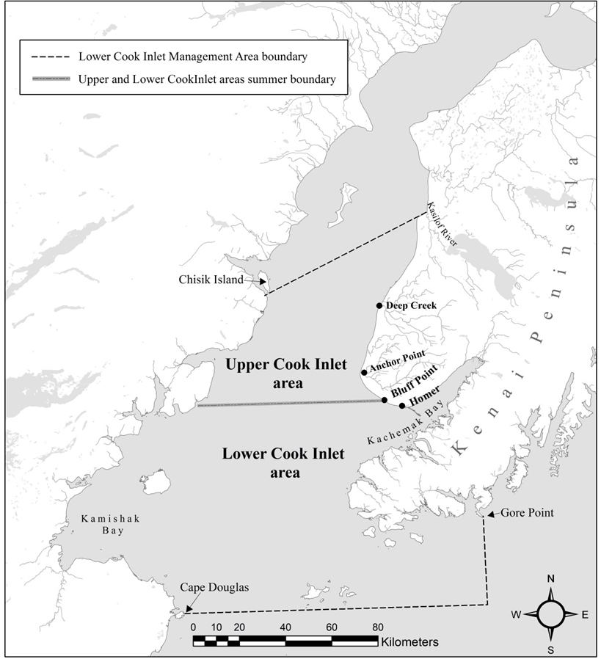

Figure .-Boundaries of the Lower Cook Inlet Management Area for Division of Sport Fish. This management area is further divided into Upper Cook Inlet area (north of Bluff Point), and Lower Cook Inlet area (south of Bluff Point including Kachemak Bay) from April 1 to August 31.

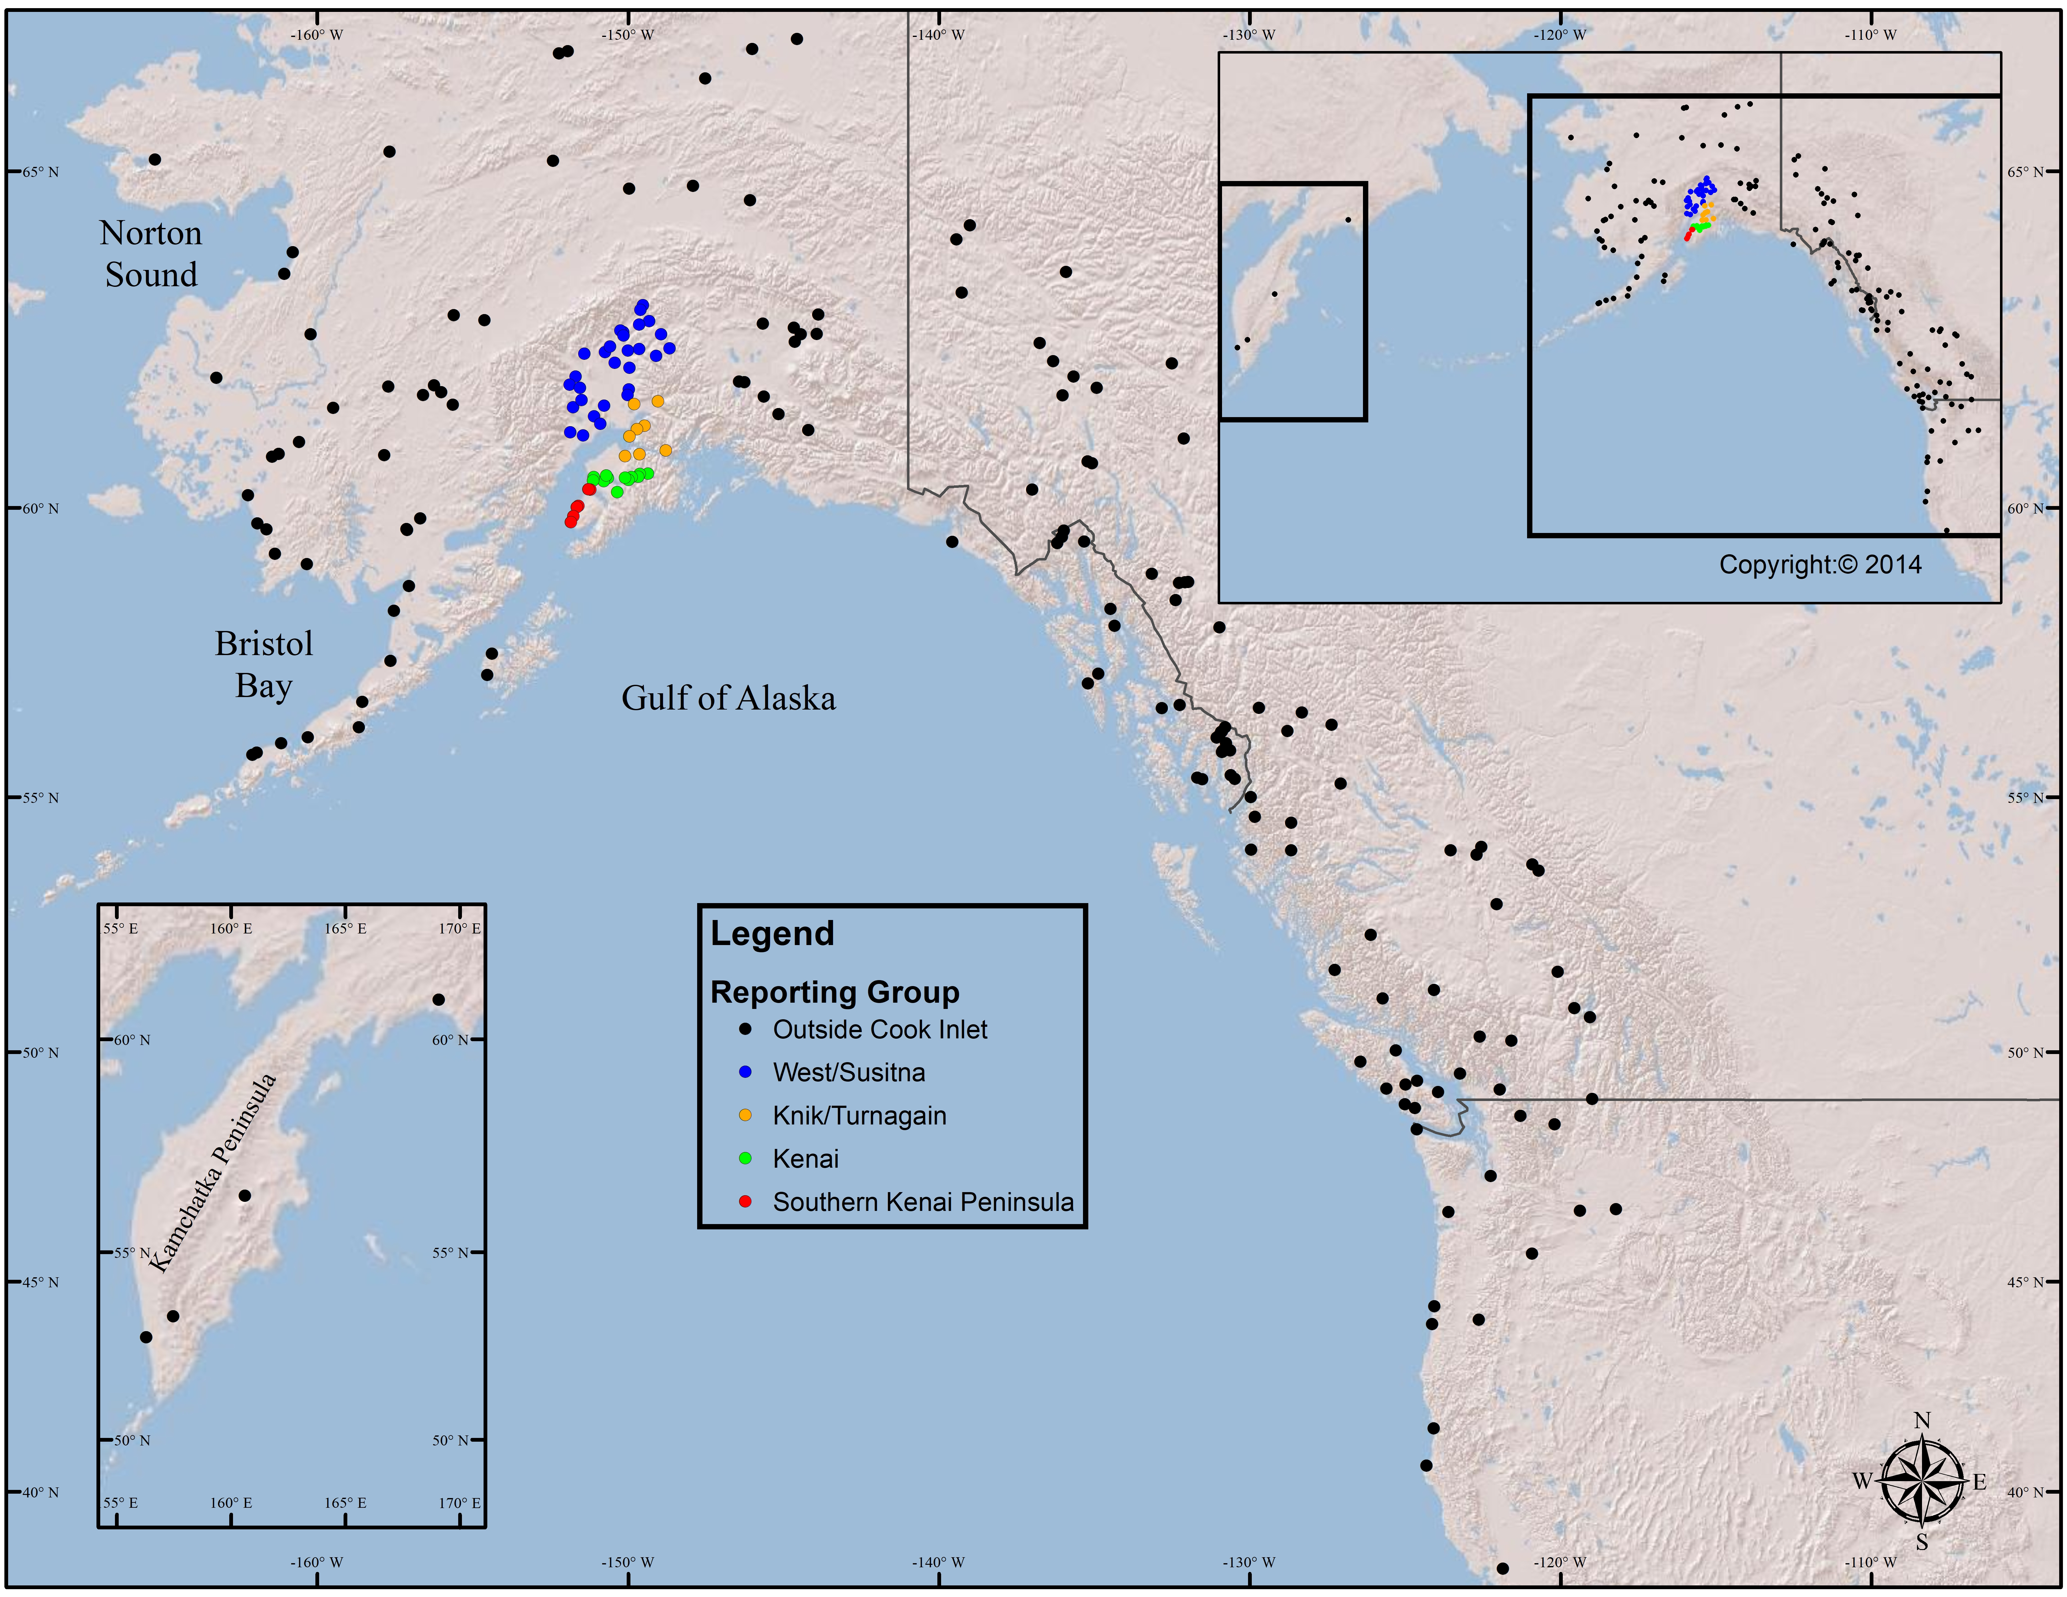

Figure .-Reporting groups .

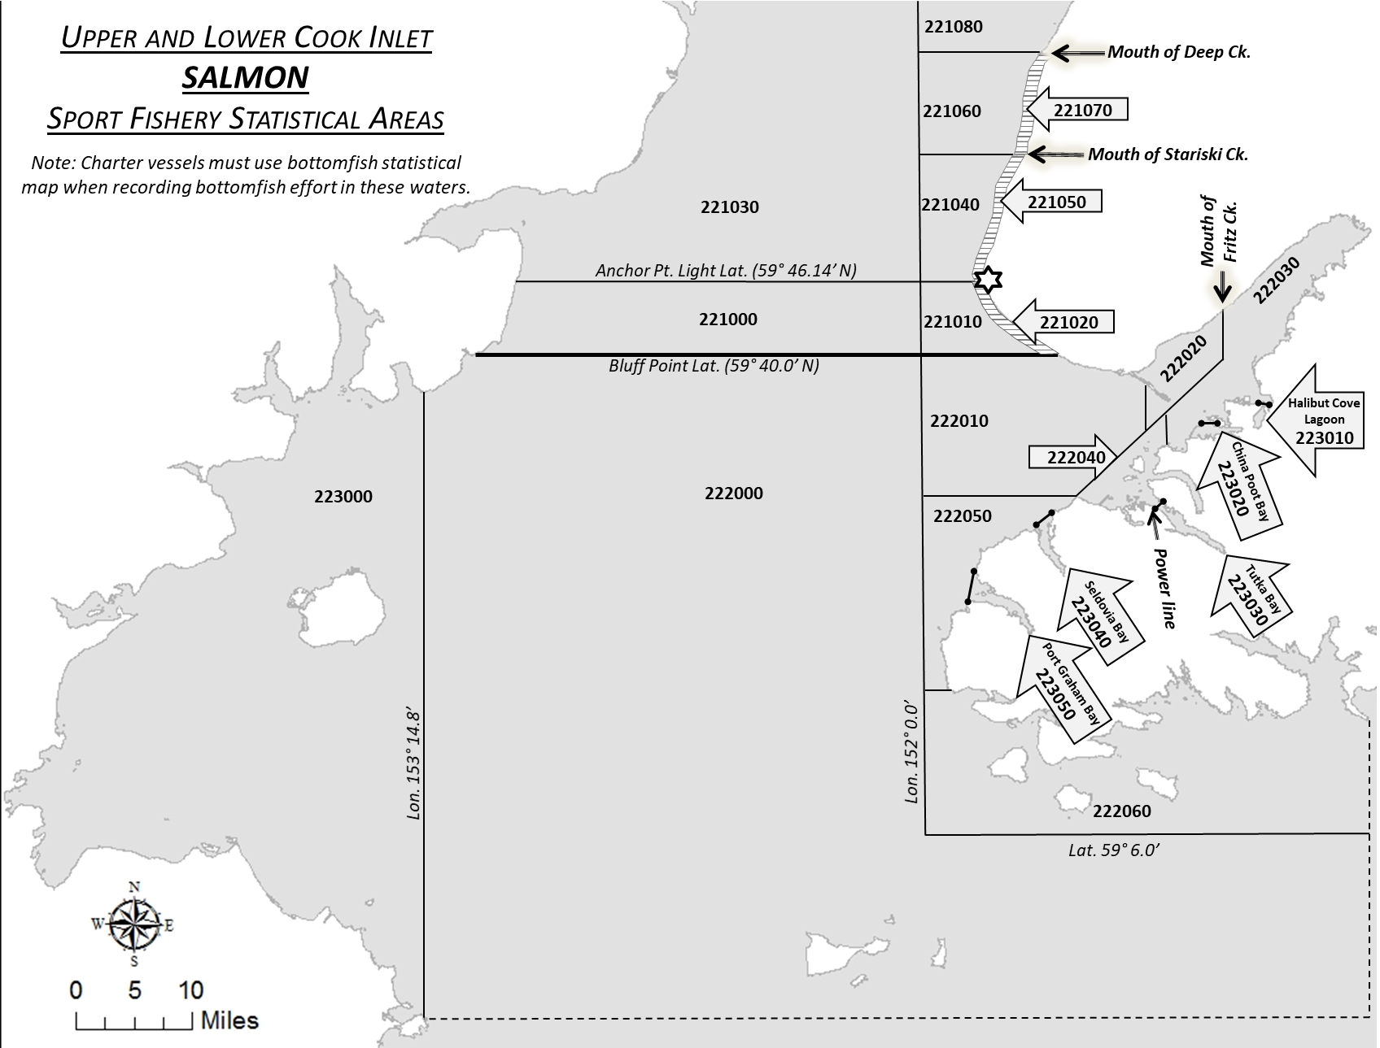

Figure .-Marine waters salmon statistical areas from approximately one mile north of the Ninilchik River south to the latitude of Cape Douglas.

# Appendix A

Appendix A1.- Species, sex, maturity, and scales.

**Salmon Species Identification**

Five species of salmon are typically caught by marine anglers in Southcentral Alaska. Use the identification guides given to you to identify species until you are familiar with them. Be aware that anglers may misidentify salmon. Recall that we are describing the Chinook salmon harvest. Common traits of Chinook salmon include: dark mouth with black gums, spots on both lobes of the tail, and large spots on the back.

**Sex**

Determine the sex of all Chinook salmon by inspection of gonads. Eggs are generally visible in ovaries which are orange in color and covered with a clear membrane whereas testes are white, flattish to triangular in cross section and composed of a solid, rubbery tissue. If for some reason you are unable to identify the sex, enter “U” (unknown) in the ASL file.

**Maturity**

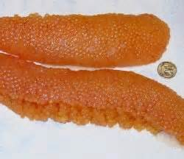

Maturing female Chinook salmon will fill and span the length of the abdominal cavity, be loosely attached in the skein with individual eggs being large and soft

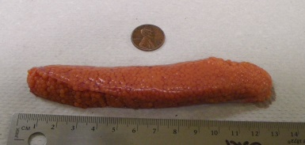

Immature Chinook salmon egg skeins have tiny tight skeins approximately one third to half the length of the abdominal cavity, with very small individual eggs within the skein.

Appendix B1.- continued

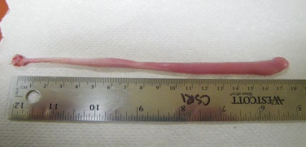

Mature male Chinook salmon will have full large soft milt sacs which also fill and span the length of the abdominal cavity.

Immature males (picture) will have small tight ribbon like milt sacs and also take up considerably less space in the abdominal cavity

**Length Measurements**

Use your measuring tape to measure the **mid-eye to fork length (MEFL)** of Chinook salmon from the midpoint of the eye, along the midline to the center of the tail (Figure 5). Measure length with the tape stretched taut and straight. Make sure your tape is not curving along the length of the body as that will result in a measurement error. Record length to the nearest 5 mm in the ASL file or paper form.

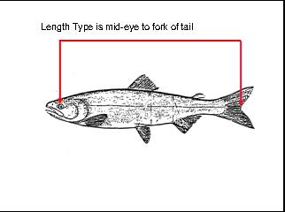

**Figure 4.** Length measurement is mid-eye to fork of tail (MEFL) rounded to the nearest 5 mm.

Remember**:** Legal length is Tip to Tip! **When an angler sees you measuring mid-eye to the fork, they will question you on it. Use the legal length to determine if large or small king (over or under 20 inches total length).**

**Scale Removal**

Collect scales after you have measured the fish.

1. The backside of the scale gum card is important and must be filled out **completely** and **accurately.** See Figure 6, next page. This should be done beforehand whenever possible with the species, date, card number, sampler name, and port filled out. (Do not use an ink pen on the scale cards! It can transfer to the acetate and/or interfere with producing a clear impression.) If some of this information is missing, especially sampling date and card number, then matching scale cards with the length data collected can be difficult to impossible at the end of the season.

Appendix A1.- continued.

1. Please **take 3 scales per fish** from the preferred area on the left side of the fish (Figure 7). **Clean each scale of dirt and grime** by rubbing scale between thumb and fingers before mounting. (This can’t be emphasized enough!) Scale samples **should not** be taken directly next to each other. See **Preferred Scale Sampling Area**. When placing scales on the gum card, remember to leave room at the top middle portion of the card so a label can be attached later. Note Figure 6 for placement of scales *per fish.*

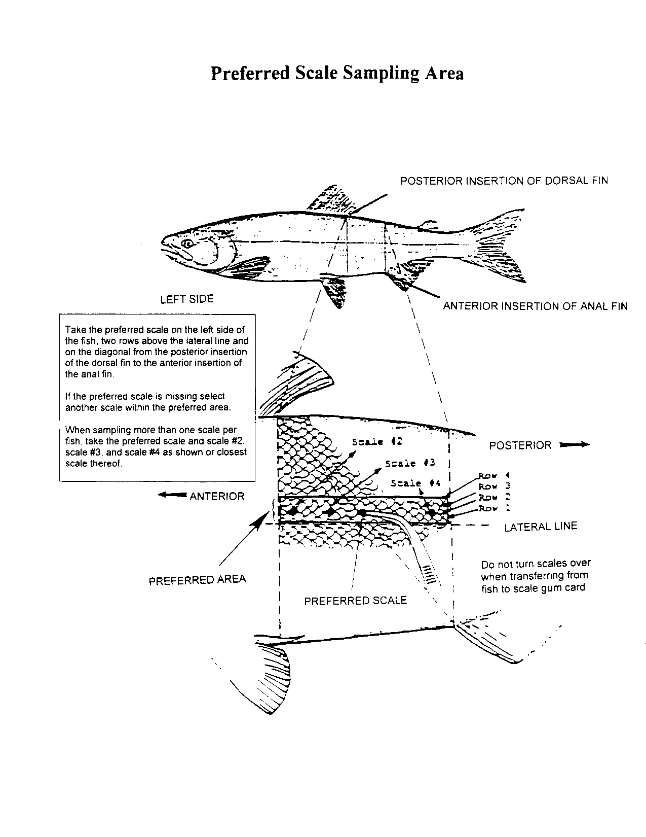

Appendix A1.- continued.

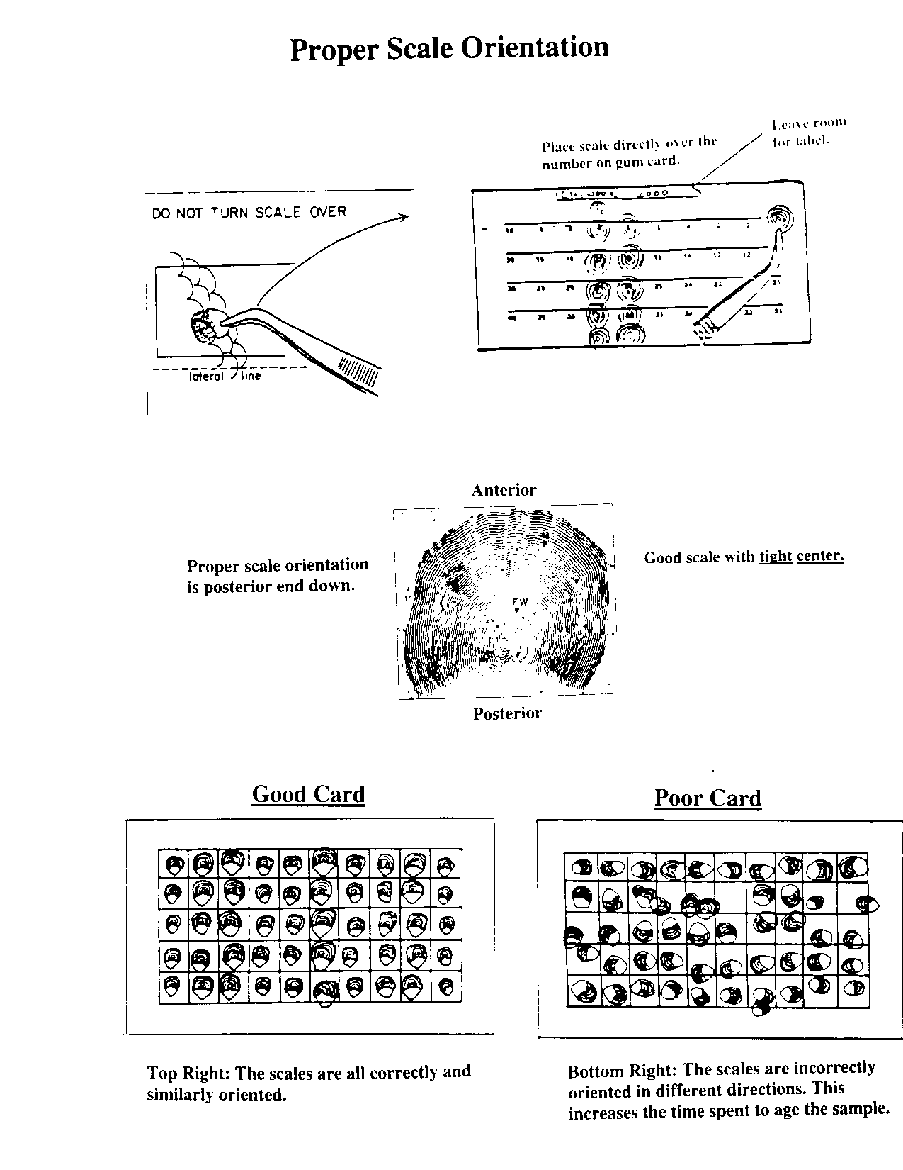

1. When possible, or if work conditions allow, hold the scale up to light to check for deformation and regeneration. Scales with these features may provide only a freshwater or marine age, but not both. **If the scale is regenerated then discard it and try again** in the next preferred area. Try the right side of the fish if there are no suitable scales on the left side.
2. Center scale on the numbered square so that the “rough” surface that faces “outwards” from the fish remains facing up on the scale card. The opposite side is smooth and featureless and impressions on acetate from such an **inverted scale cannot be aged**.
3. Before adhering scale to the gum card, moisten and orient scale posterior side down. See **proper scale orientation** sheet in Figure 8.
4. **It is extremely important to keep gum cards dry.** Excessive moisture will dissolve the card’s glue and cover or wash scales out of alignment. Scales cannot be aged when glue runs – blocking the scale’s imprint.

Appendix A1.- continued.

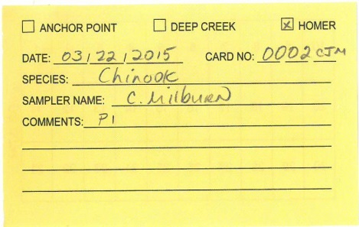

Front side of a scale card.

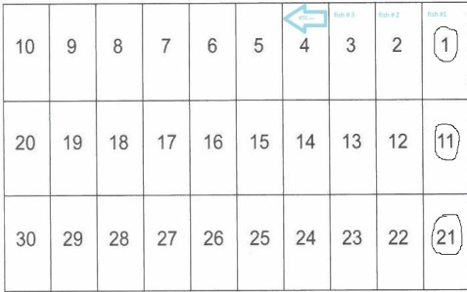

Back side of scale card (adhesive).

Appendix A2.- Genetic samples.

Procurement of the genetic sample entails the removal of the Chinook salmon’s axillary process located at the base of the salmon’s pelvic fin. Using your nail clippers, carefully remove approximately ½ - ¾ inch (if possible as some appendages may be smaller) of the axillary process and place it onto the appropriate numbered grid space on a Whatman card. These samples require special care to ensure the tissue is properly preserved for the Gene Conservation Lab. See below for the proper collecting and preserving methods of these samples.

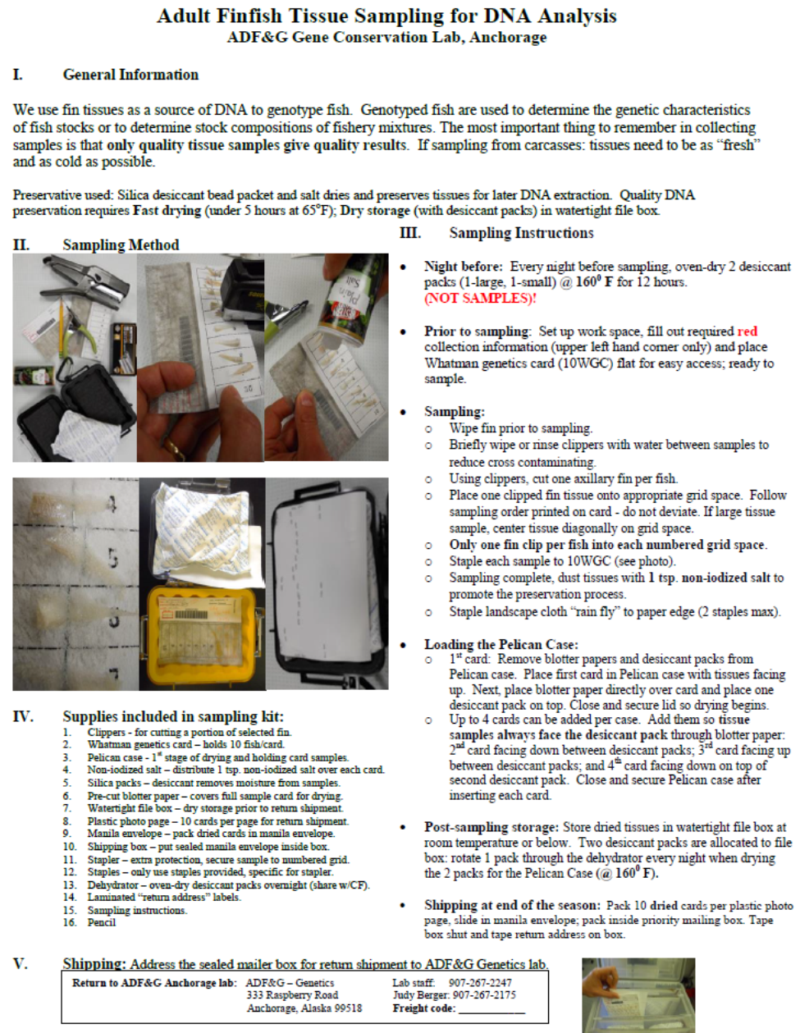

Appendix A3.- Coded-wire tag sampling

This information is recorded on a Coded Wire Tag (CWT) Sampling Form (Figure 10)

**Interviewer Information**

**Sample Number:** Leave the sample number blank (it will be filled in by your crew leader later).

**Source:** Circle “SPORT”

**Survey Site** (record one of the following locations):

* Anchor Point
* Deep Creek
* Homer
* Other (e.g. Whiskey Gulch)

**Sample Type:** Circle “**random**” if the fish is randomly sampled by you during your survey time. Circle “**select**” if the head is voluntarily brought in by an angler (you would not have encountered them during your shift, or they may have retained that fish on your day off but kept it until they encountered you on a regular work day).

**Sampler:** Record your last name.

**Name of place sampled:** This is recorded for random heads only. Record the name of the harbor or boat launch sampled.

**Date sampled:** Record the month and day the fish was sampled for random heads. For select heads, record when the fish was caught.

**Stratification Information**

**Sport Harvest Code** (record for randomly sampled heads only):

**M**arine **B**oat (usually this code is entered)

**D**erby **E**ntered (Homer and Anchor Point Derbies)

**D**erby **T**ake home (Homer and Anchor Point Derbies)

**M**arine **R**oadside (Fishing Lagoon only)

**Angler Information**

Name and mailing address of angler catching fish. Leave blank if they do not want the information sent to them. Complete one form for the vessel, multiple anglers can be listed on a single form (or email addresses). Do not fill in your name and address.

**Catch Information**

**Date Caught:** Record month and day the fish was caught.

**Water Type:** Circle saltwater (usually) or freshwater (**only** possible with select samples).

**Name of Place Fished:** Record the area where fish was caught, being as specific as possible, including a descriptor of the area.

**Area Information & Anadromous Stream #:** Leave blank.

Appendix A3.- continue.

**Sampling information**

**Species Code:** Record in the blanks next to the species being sampled: usually (410 CHIN) for our purposes.

**Head Recovery Information**

**Head Number:** Each port sampler will be issued a specific series of Coded Wire Tags. Record the 6-digit cinch strap number assigned to head of fish. Hint: If you are busy, strap the jaw of the adipose clipped fish prior to sampling it and inform the angler of the needed recovery. This helps remind the angler and yourself that it is an ad-clipped salmon. Many heads have been lost when the angler is cleaning the fish and forgets! All ad-clipped fish must have a designated jaw strap, even if you do not recover the head. If the fish is lost, attach the jaw strap to the CWT form. If the head with the jaw strap is lost, record the jaw strap number and write on the form: head and jaw strap lost.

**Species Code:** Record appropriate species number: 410 for Chinook (king) salmon.

**Fork Length:** Record the length from MEFL to nearest 5 millimeters. This measurement should match your AWL.

**Clip Status:** Circle "Good" if the adipose looks to be cleanly sliced off and healed, circle "???" if the adipose looks like it may have been torn off or looks questionable, and circle "Unkn" if only the head is seen, or if a head is turned in to you by an angler.

**Chinook Flesh Color:** Circle the appropriate flesh color. This should also match your ASL form

IMPORTANT NOTE: It is very important that we account for every fish head and every tag. If you turn in a form for a fish head that you did not put it in the usual place (i.e., designated CSRI freezer) please note **WHERE** this head is in the **upper right hand corner of the form**: e.g., fish head lost by angler at cleaning table, or fish head in Comm. Fish freezer, or forgot fish head at home freezer.

**Sex:** (M) Male, (F) Female, (U) Unknown

Matching up the fish heads to the CWT forms prior to shipping can be a big time waster for the shippers. They go through each strapped head, verify the number and check it off. They also check your summaries for the number of heads you collected. These numbers should match up. This should help this process be more efficient**. Ensure that all heads listed on your summary are accounted for and that all heads are listed on your summary**.

Please check the jaw straps to make sure the number is easily read as it is difficult if not impossible to adjust when the head is frozen.

Appendix A3.- continue

Appendix A3.- continue

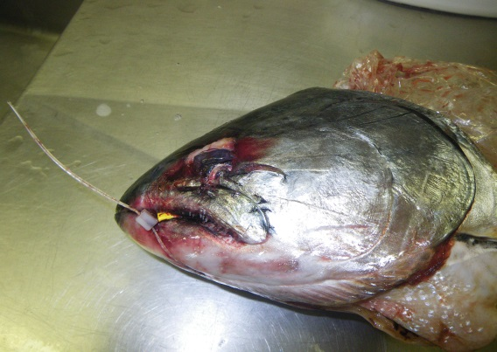

Improper tag placement. The tag should be oriented, so it can be read when the head is frozen. Here the tag number is in the mouth of the fish. In order to be able to read the tag, the fish would need to be thawed.

# Appendix B

Appendix B.- Technician field Schedule, 2018.



-continued-

Appendix B.- Page 2 of 3.



-continued-

Appendix B.- Page 3.of 3.



# Appendix C

Appendix C.-Biological and interview data entry form.

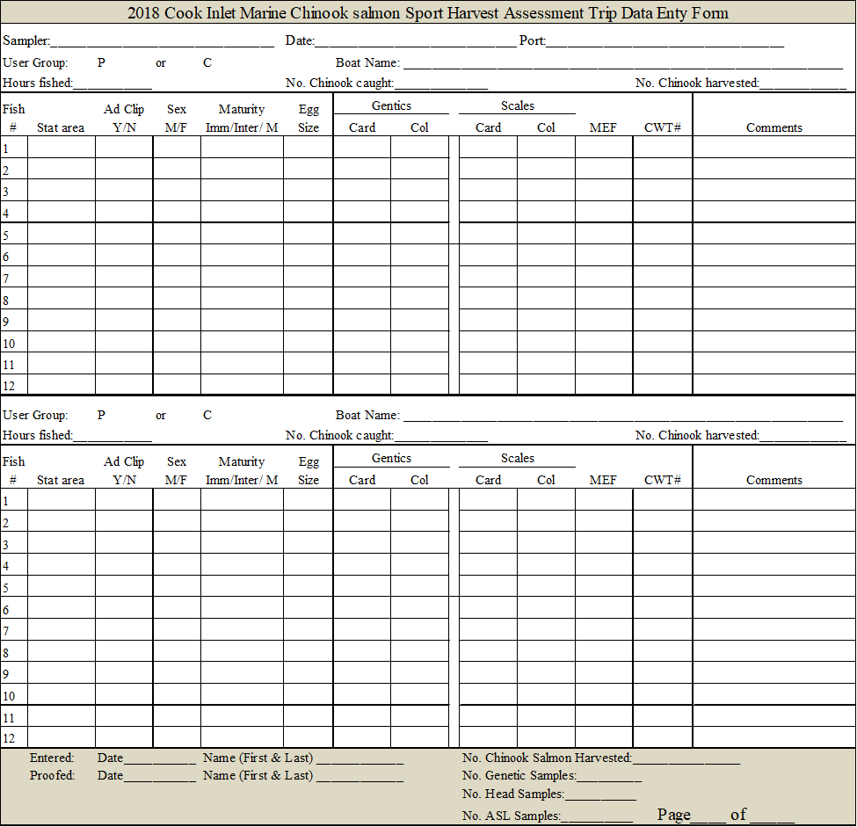

1. Referred to as Central Cook Inlet (CCI) prior to 2017.